**EXPERIMENT:4**

**Create a simple cloud software application for Library book reservation system for SIMATS library using any Cloud Service Provider to demonstrate SaaS include the necessary fields such as Title of the book, author, publications, Year, edition, no of copies, Rack no, status (taken/returned) etc.**

**AIM:**

To Create a simple cloud software application for Library book reservation system for SIMATS library using any Cloud Service Provider to demonstrate SaaS

**PROCEDURE:**

**step1:** Go to zoho.com.

**step 2:** Log into the zoho.com.

**step 3:** Select one application step.

**step4:** Enter application name as library book reservation system.

**step 5:** Created new application as library book reservation system.

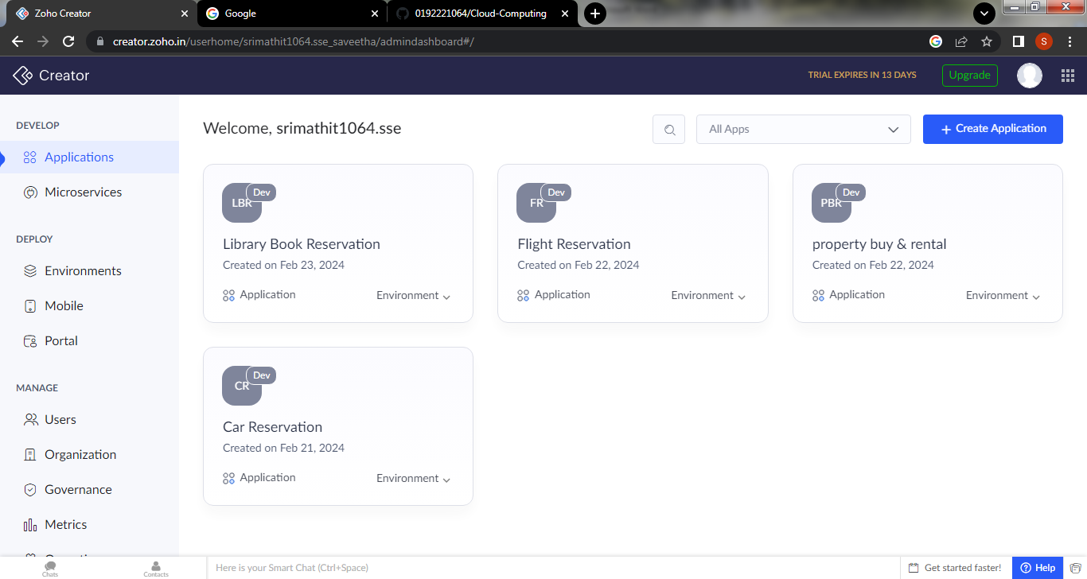

**Step 6: create a first form of login page for the student or user**

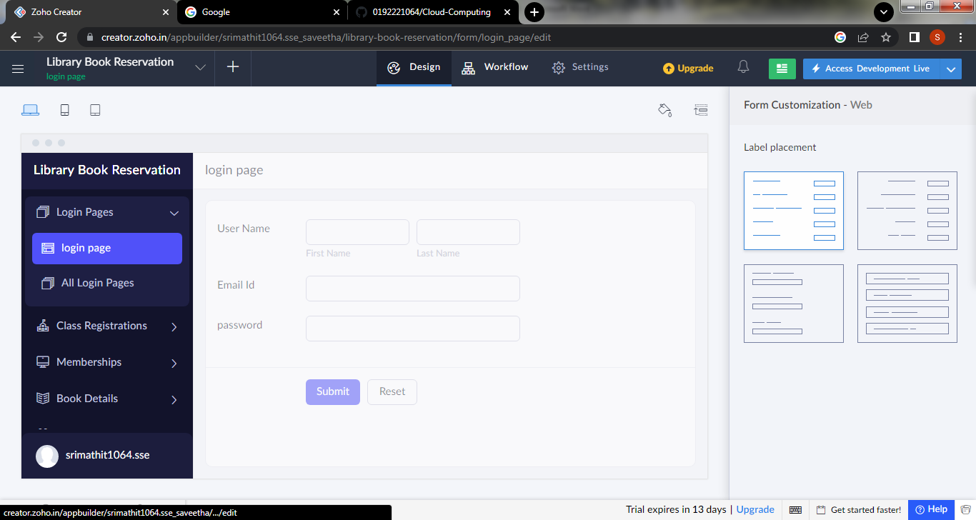

**Step 7: create second form for the class Registration**

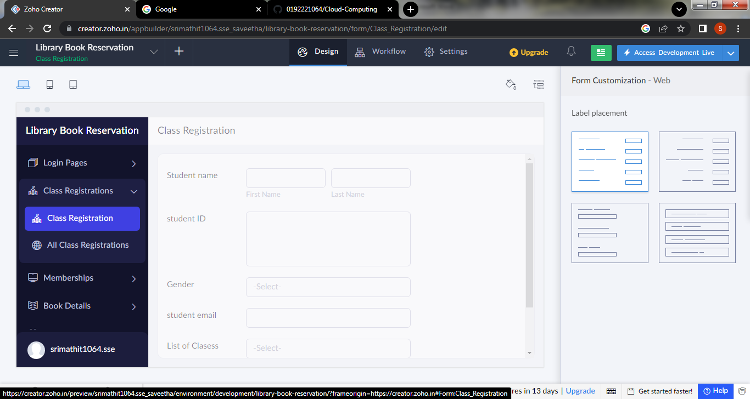

**Step 8: create a third form for the membership**

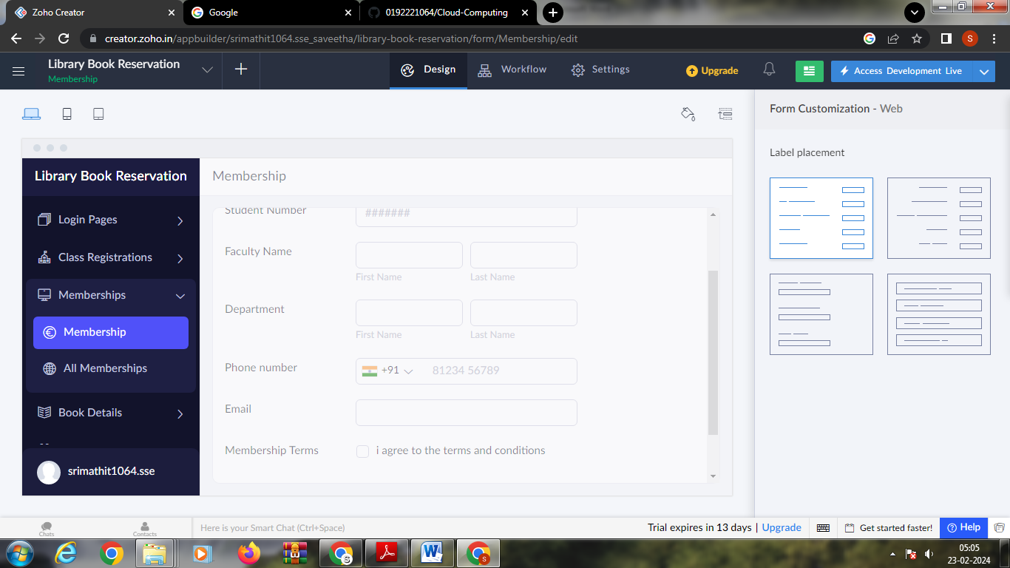

**Step 9: create next form for book details**

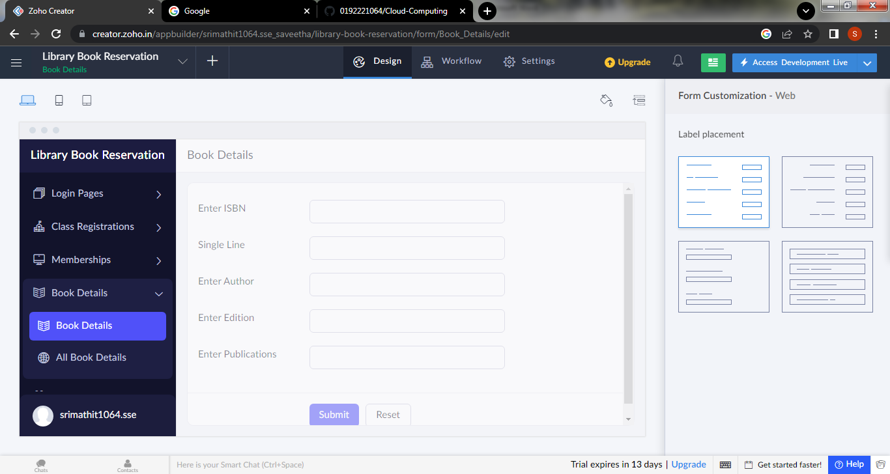

**Step 10: create the form for confirmation of the book selected**

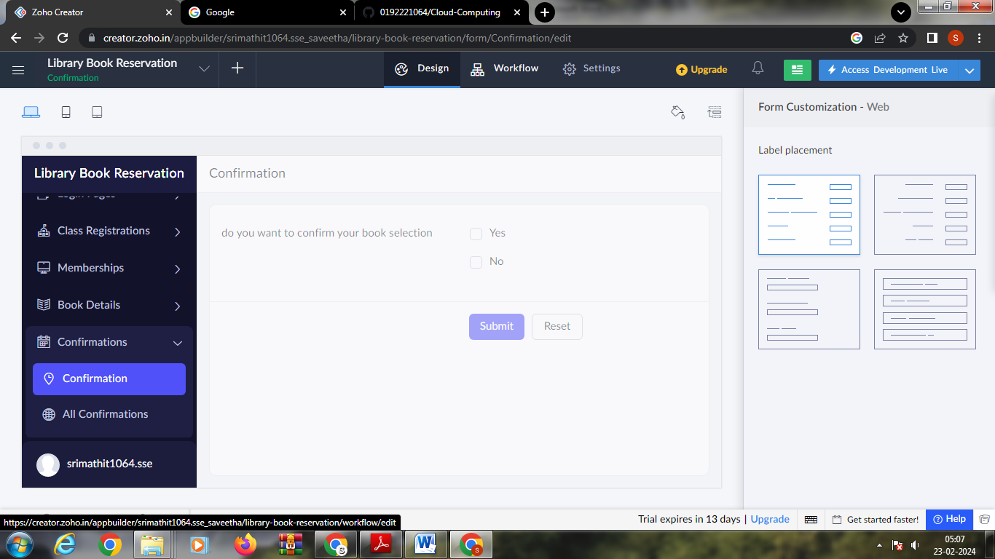

**Step 11: click on the access development to see the live output**

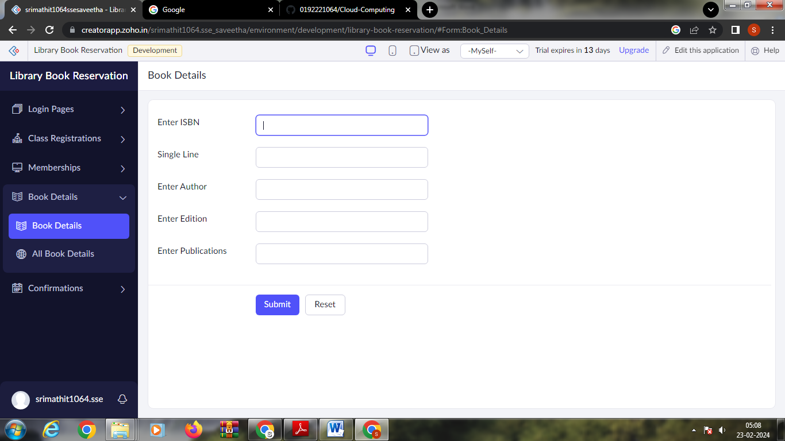

**Step 12: click the reports to view the data**

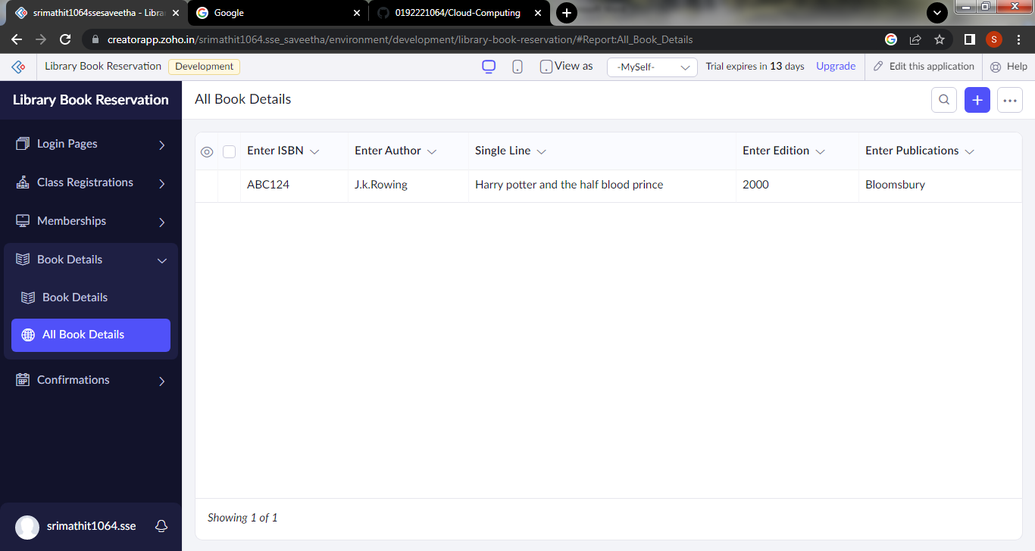

**Step 13: click the mobile icon to view the output in mobile view**

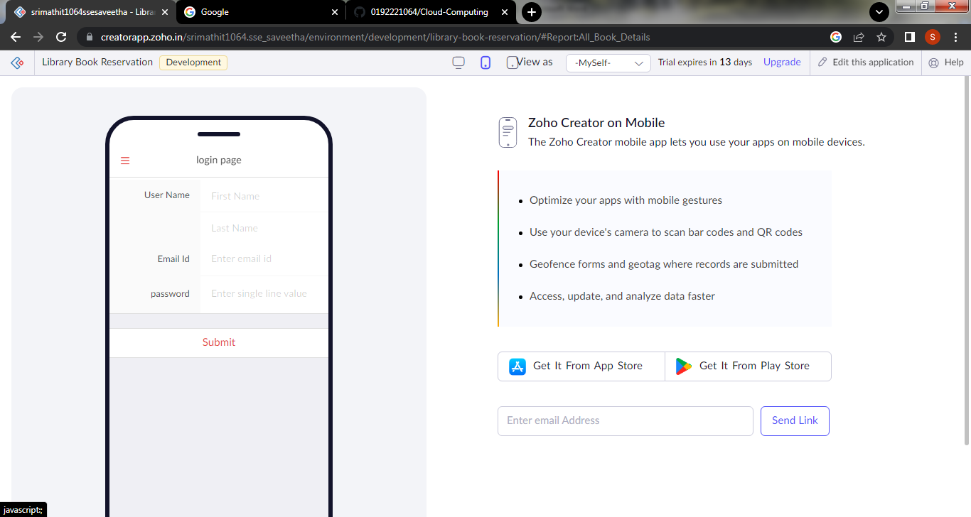

**Step 14: click the tablet icon to view the output in tablet view**

